American Legal Systems Summer Tour
19 days

Saturday, Day 1

Arrival Day (Stay with host family)
Pick up from Detroit Airport
Welcome dinner with host families
Go home with host families, experience typical American family life

Sunday, Day 2

Host Family Day (Stay with host family)
Students have a fun-filled day doing activities with their host families

Monday, Day 3

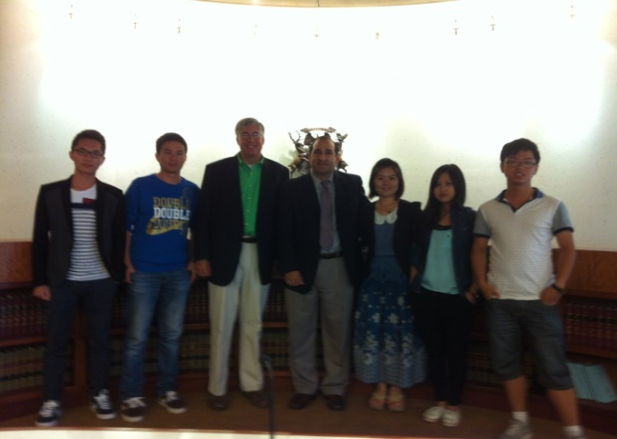
Introduction to State & Federal Court Systems (Stay with host family)
Program introduction by MCEP Board Secretary, Ed Bruley
Introduction to Michigan and Federal Court System by University Professors
Afternoon cultural activity

Tuesday, Day 4

District Court System Day (Stay with host family)
Visit local District Court, which handles misdemeanors, traffic fines, small claims, etc
Watch arraignments at the District Court
Tour District Courthouse
Question & Answer session with a District Court Judge

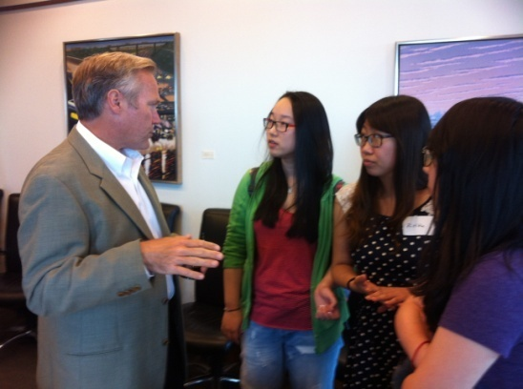
Wednesday, Day 5

Circuit Court System Day (Stay with host family)
Visit Circuit Court, which hears both civil and criminal cases, as well as appeals from other courts
Tour jury rooms and learn about jury selection process
Learn about Circuit Courts by use of role-play exercise
Meet with Circuit Court Judge
Visit small law firm and meet with attorneys, learning about day-to-day practice
Go to a driving range for golf practice and instruction

Thursday, Day 6

Federal Court Day (Stay with host family)
Visit United States Federal District Court
Watch motion hearings
Meet with a US Federal District Court judge
Tour courtrooms and attend presentation by U.S. Marshal’s office
Meet with US Attorney for the Eastern District of Michigan

Friday, Day 7

Court of Appeals and State Supreme Court (Stay with host family)
Visit Detroit Institute of Arts, a world-renowned art museum
Visit and learn about the Michigan State Court of Appeals
Attend lecture and discussion with Michigan State Supreme Court Justice ad Court of Appeals Judge

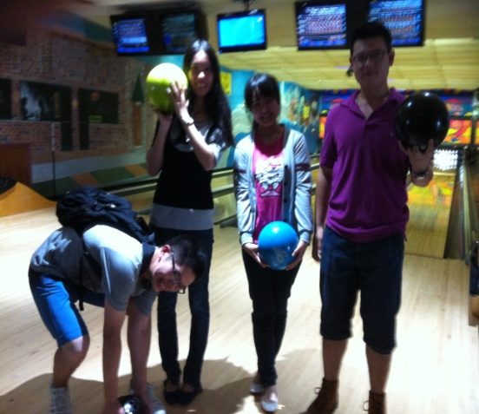
Saturday, Day 8

Host Family Day (Stay with host family)
Students have a fun-filled day doing activities with their host families

Sunday, Day 9

Host Family Day (Stay at hotel)
Students have a fun-filled day doing activities with their host families (last day with host families)
Check into hotel for the remainder of the nights in Michigan

Monday, Day 10

Internship Day (Stay at hotel)

Court Internships – students will be in the courtroom of a Circuit, District, or Probate Court Judge, in groups of two, learning firsthand the court processes
Picnic at Lake St. Clair Metropark and boating on Lake St. Clair

Tuesday, Day 11

Internship Day (Stay at hotel)
Court Internships – students will be in the courtroom of a Circuit, District, or Probate Court Judge, in groups of two, learning firsthand the court processes
Shopping at Great Lakes Crossing Outlet Mall

Wednesday, Day 12

Internship and Shopping Day (Stay at hotel)
Court Internships – students will be in the courtroom of a Circuit, District, or Probate Court Judge, in groups of two, learning firsthand the court processes
Lunch with Judges and MCEP Law Program Certificate presentation
Visit a golf course and play 9 holes of golf

Thursday, Day 13

University Day (Stay at hotel)
Visit the University of Michigan Law School, one of the top ten law schools in the U.S.
Tour University of Michigan Law Library
Visit Wayne State University, a public research university located in the city of Detroit
Tour Wayne State University law school
Reception in afternoon at local Law Firm

Friday, Day 14

Travel to Washington, D.C. (Stay at hotel)
Go to Detroit Metro Airport and fly to Washington D.C.
Visit the Georgetown neighborhood of Washington D.C., home of Georgetown University
Shop at stores on Wisconsin Ave and M St

Saturday, Day 15

Washington D.C. (Stay at hotel)
Walk by the White House, home of the President of the United States
Visit national monuments such as Washington Monument, Lincoln Memorial, Martin Luther King Jr. Memorial, Thomas Jefferson Memorial, and Franklin Delano Roosevelt Memorial

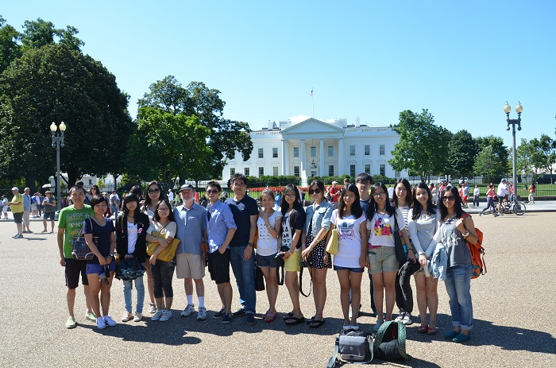
Sunday, Day 16

Washington D.C. (Stay at hotel)
Visit National Archives building, home of the United States Declaration of Independence, the Constitution, and the Bill of Rights
Visit museum on the National Mall. Choose one:
- Air and Space Museum
- African American History and Culture Museum
- African Art Museum
- American History Museum
- American Indian Museum
- Freer Gallery of Art
- Hirshhorn Museum and Sculpture Garden
- Natural History Museum, Postal Museum
- Sackler Gallery
- Smithsonian Castle
- Ripley Center International Gallery

Monday, Day 17

Washington D.C. (Stay at hotel)
Visit United States Supreme Court, watch documentary film and lecture
Lunch at the Supreme Court Cafeteria
Visit the Library of Congress, the national library of the United States
Tour United States Capitol Building – House of Representatives
Dinner in the Chinatown neighborhood of Washington D.C.

Tuesday, Day 18

Departure Day (Stay at hotel)
Check out of hotel and travel to airport
Fly to the People’s Republic of China

Wednesday, Day 19

Arrival Day
Arrive at the Airport in China

Appendix
Host Families: Students will stay the first week with an American family. Each family has volunteered to provide home-cooked meals and an inside glimpse at typical American lifestyles.
Michigan Cultural Experiences
Boating on Lake St. Clair and the Detroit River: Lake St. Clair is a fresh-water lake that lies between the state of Michigan, United States, and the province of Ontario, Canada. This lake is the busiest lake in the world for recreational boating. The Detroit River connects Lake St. Clair to Lake Erie, one of the Great Lakes.
Henry Ford Museum: The Henry Ford Museum is a collection of items of historical significance celebrating American inventors and innovation. The museum began as Henry Ford’s private collection of historic objects. It is now primarily a collection of antique machinery, pop culture items, automobiles, locomotives, and aircraft. It is home to President Abraham Lincoln’s chair from the Ford Theatre, President John F. Kennedy’s limousine and the Rosa Parks bus.
Ford Rogue Factory Tour: The Ford Rouge Factory Tour is a five-part adventure where visitors see how cutting-edge environmental practices and industrial innovation mesh to create one of the world’s most enlightened and forward-looking factories. Students will see Ford F-150 trucks in production as well as the world’s largest living roof.
Detroit Institute of Arts (DIA): The DIA is an art museum with one of the largest, most significant art collections in the United States. In 2003, the DIA ranked as the second largest municipally-owned museum in the United States, with an art collection valued at more than one billion dollars. With over 100 galleries, it covers 658,000 square feet (61,130 m²); a major renovation and expansion project completed in 2007 added 58,000 square feet (5,388 m²).
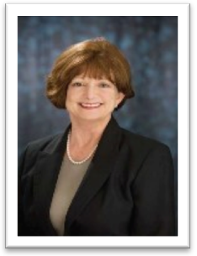
Professor Anne M. Burr
Guest Professor, American Legal System Tour, Macomb Cultural and Economic Partnership - China University of Political Science and Law. Part-time Clinical Professor, Legal Practice Program, University of Michigan Law School. Former Academic Director, Legal Research and Writing Program, Wayne State University Law School. Former Visiting Assistant Professor in the Legal Practice Program, Peking University School of Transnational Law
Anne M. Burr will be teaching U.S. practice skills to foreign students in the L.LM. program at the University of Michigan Law School in the fall of 2013. During the period from 2008-2013, she was the Academic Director of Legal Research and Writing at Wayne State University Law School and also served as a Visiting Assistant Professor at Peking University’s School of Transnational Law (“STL”).
As an Academic Director of Legal Research and Writing at Wayne Law, Professor Burr was responsible for designing and implementing a legal practice program that integrated analysis, research, writing, oral advocacy, transactional drafting, and other aspects of the practice of law. As a Visiting Assistant Professor at STL, Professor Burr assisted in designing and implementing the legal practice program for the first western style law school in China. Launched in 2008 in Shenzhen, STL seeks to provide its students with the practice skills necessary to achieve success in global law firms.
Professor Burr began her legal career as a federal law clerk for U.S. District Judge George E. Woods, before joining the regional law firm of Dykema Gossett. Becoming an equity partner in 1989, she specialized in corporate workouts. She was also one of three finalists in 1989 for an appointment as a U.S. Bankruptcy Court Judge for the Eastern District of Michigan.
Following her tenure at Dykema, Professor Burr served as senior counsel of the multinational corporation Allied Domecq, PLC. Responsible for mergers, acquisitions, and divestitures for the wines and spirits division, she worked on transactions in Mexico, South America, and Asia.
In addition to her positions at Wayne Law and STL, Professor Burr has taught as a visiting or assistant professor at Detroit College of Law, Ave Maria School of Law, and Wayne State University Schools of Business and Communications. She has taught subjects as diverse as civil procedure, debtor-creditor law, negotiation, writing and analysis, legal research, and legal drafting.
An avid writer, Professor Burr has published various articles on practice skills, alternative dispute resolution, and her experiences teaching at STL. Professor Burr is co-authoring a book “U.S. Legal Skills for Foreign Students” with Professor Howard Bromberg. The book will be published by Carolina Academic Press next year.

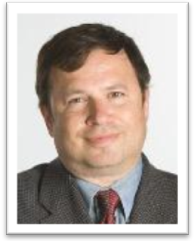
Professor Howard Bromberg
Clinical Assistant Professor, University of Michigan Law School. Former Visiting Professor and Director of the Legal Practice Program, Peking University School of Transnational Law
Howard Bromberg teaches in the Legal Practice Program at the University of Michigan Law School, where he also taught from 1996 to 2000. Prior to returning to Michigan Law, he was Associate Professor of Law and Assistant Dean of Clinical and Professional Skills Programs at the Ave Maria School of Law in Ann Arbor. He has published numerous articles and entries on subjects in law, legal history, and biography, and edited the recently published three-volume Great Lives From History: The Incredibly Wealthy. From 2001 to 2003, he was a visiting professor at Harvard Law School, where he helped establish the new First-Year Lawyering Program and served as its Associate Director. From 2008 to 2010, he designed and directed the legal writing program at the newly-created Peking University School of Transnational Law, where he was also a visiting professor. Professor Bromberg has also taught at Chicago and Stanford Law Schools. Before entering the academy, he practiced law as an assistant district attorney in the Appeals Bureau of the New York County District Attorney's Office and as legislative counsel to Congressman Thomas Petri of Wisconsin. Professor Bromberg received his B.A and J.D. degrees from Harvard Law School and his J.S.M degree from Stanford Law School.
Professor Bromberg is co-authoring a book “U.S. Legal Skills for Foreign Students” with Wayne State University Law School Professor Anne Burr. The book will be published by Carolina Academic Press next year.
Professor Bromberg has written about his experience teaching law in China in his articles , "Teaching Legal History through Legal Skills," American Journal of Legal History, vol. 53, No. 4 (October 2013) and “Peking University School of Transnational Law: A New Venture in International Legal Relations,” 1 Ave Maria Intern. L. J. 1, 114-123 (2009). He has presented his experiences teaching in China in academic conferences at City Law School, City University, London, UK (2013), at the AALS Section on Legal Writing, Reasoning, and Research, Washington, D.C., January 7, 2012 and at the Global Legal Skills Conference VI, John Marshall Law School, Chicago, May 7, 2011. He has taught law students from CUPL in the summers of 2012 and 2011.

